ASSIGNMENT

1. WAP to swap two numbers using template function.
2. WAP to implement bubble sort using function template
3. WAP to implement queue using class template.
4. WAP Simple calculator using Class template

#include <iostream>

using namespace std;

template <typename T>

class Calculator {

public:

T add(T a, T b) {

return a + b;

}

T subtract(T a, T b) {

return a - b;

}

T multiply(T a, T b) {

return a * b;

}

T divide(T a, T b) {

if (b == 0) {

cout<< "Error: Division by zero." <<endl;

return static_cast<T>(0);

}

return a / b;

}

};

int main() {

Calculator<int> intCalculator;

Calculator<float> floatCalculator;

int a = 10, b = 5;

float x = 10.5, y = 2.5;

// Integer calculations

cout << "Integer Calculations:" <<endl;

cout << "Addition: " << intCalculator.add(a, b) <<endl;

cout << "Subtraction: " << intCalculator.subtract(a, b) <<endl;

cout << "Multiplication: " << intCalculator.multiply(a, b) <<endl;

cout << "Division: " << intCalculator.divide(a, b) <<endl;

// Floating-point calculations

cout << "\nFloating-Point Calculations:" <<endl;

cout << "Addition: " << floatCalculator.add(x, y) <<endl;

cout << "Subtraction: " << floatCalculator.subtract(x, y) <<endl;

cout << "Multiplication: " << floatCalculator.multiply(x, y) <<endl;

cout << "Division: " << floatCalculator.divide(x, y) <<endl;

return 0;

}

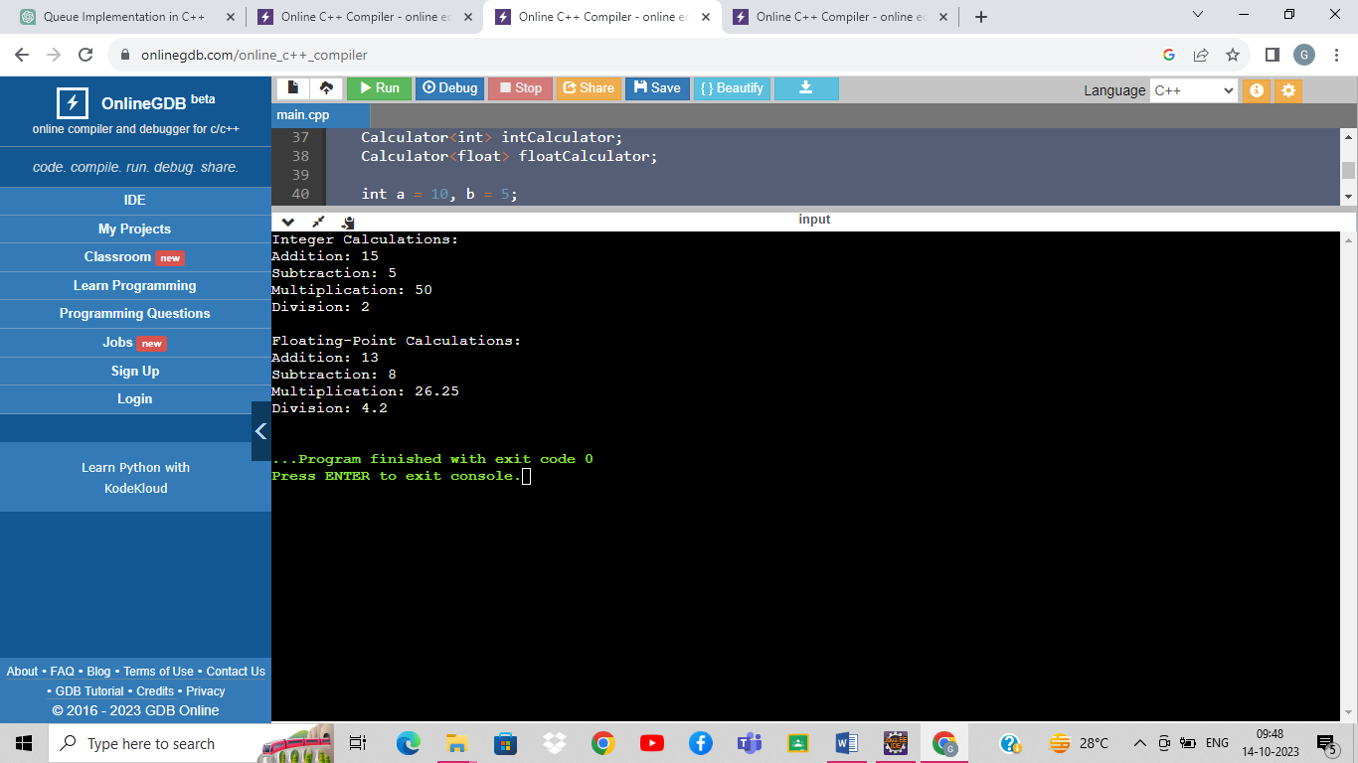

1. WAP Exception Handling for Divide by zero condition for the division of two numbers.
2. WAP for multiple catch statements to handle various types of exceptions for 3 different values of a variable w.r.t int,char,double throws.
3. Wap to read from a file and print on console.

#include <string>

using namespace std;

int main() {

string filename;

cout << "Enter the file name or path: ";

cin >> filename;

ifstream file(filename);

if (!file.is_open()) {

cout << "Error: Unable to open the file." <<endl;

return 1;

}

string line;

while (getline(file, line)) {

cout << line << endl;

}

file.close();

return 0;

}

1. WAP to create a file and write data on it.

#include <iostream>

#include <fstream>

#include <string>

using namespace std;

int main()

{

string filename;

cout << "Enter the file name: ";

cin >> filename;

ofstream file(filename);

if (!file.is_open())

{

cout<< "Error: Unable to create or open the file." <<endl;

return 1;

}

string data;

cout << "Enter data to write to the file (type 'exit' to finish):\n";

while (true) {

std::getline(std::cin, data);

if (data == "exit") {

break;

}

file << data << '\n';

}

file.close();

cout << "Data has been written to the file." <<endl;

return 0;

}

1. WAP to copy the data of one to other file;

#include <iostream>

#include <fstream>

#include <string>

using namespace std;

int main()

{

string sourceFilename, destinationFilename;

cout << "Enter the source file name: ";

cin >> sourceFilename;

ifstream sourceFile(sourceFilename);

if (!sourceFile.is_open()) {

std::cerr << "Error: Unable to open the source file." << std::endl;

return 1;

}

cout << "Enter the destination file name: ";

cin >> destinationFilename;

ofstream destinationFile(destinationFilename);

if (!destinationFile.is_open()) {

std::cerr << "Error: Unable to create or open the destination file." <<endl;

return 1;

}

string line;

while (std::getline(sourceFile, line)) {

destinationFile << line << '\n';

}

sourceFile.close();

destinationFile.close();

cout << "Data has been copied from the source file to the destination file." <<endl;

return 0;

}